Alex Arnold
Professor Torres
4-3-25
IT 120-41198
Lab 9

Part A:
Capture a screenshot of the results of each major command. Log on to Netlab2Links to an external site. (NISGTC Linux+ Series 2, Lab 01). Configure the below settings on the Ubuntu Workstation
Version Ubuntu 12.04 LTS
3.6 Firewall Configuration

6.1 Ensure iptables is installed (Scored)
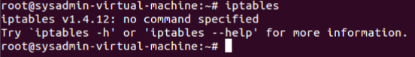
6.2 Ensure default deny firewall policy (Scored)
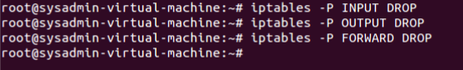
6.3 Ensure loopback traffic is configured (Scored)
6.4 Ensure outbound and established connections are configured (Not Scored)
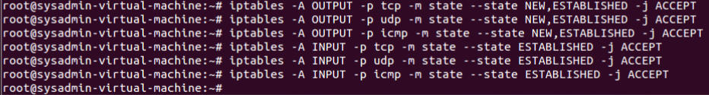
6.5 Ensure firewall rules exist for all open ports (Scored)
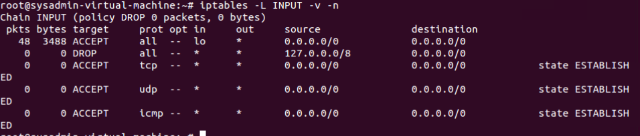

5.4.1 Set Shadow Password Suite Parameters

5.4.1.1 Ensure password expiration is 365 days or less
5.4.1.2 Ensure minimum days between password changes is 7 or more
5.4.1.3 Ensure password expiration warning days is 7 or more

5.4.1.4 Ensure inactive password lock is 30 days or less

4.1.1 Configure Data Retention (Configure System Accounting)
Can Not be done as auditd does not exist on the system and it has no Internet connection.
1.1.1 Ensure audit log storage size is configured (Not Scored)
1.1.2 Ensure system is disabled when audit logs are full (Scored)
1.1.3 Ensure audit logs are not automatically deleted (Scored)
1.8 Ensure login and logout events are collected (Scored)
1.9 Ensure session initiation information is collected (Scored)
1.16 Ensure system administrator actions (sudolog) are collected (Scored)
1.18 Ensure the audit configuration is immutable (Scored)

  - System File Permissions

  - Audit system file permissions (Not Scored)
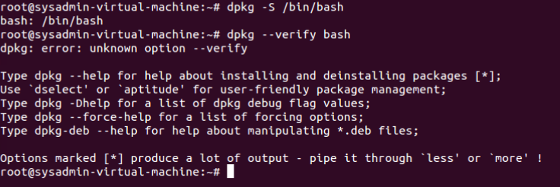
Dpkg can be used to determin which package the files belong to but the –verify command is unrecognized meaning that the activity can not be completed.
  - Ensure permissions on /etc/passwd are configured (Scored)
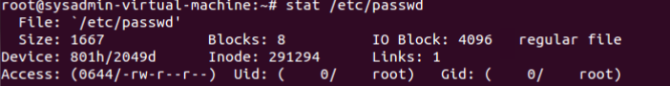
  - Ensure permissions on /etc/shadow are configured (Scored)
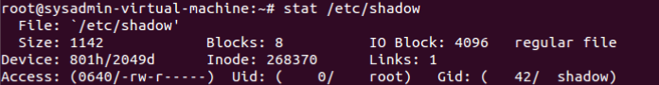
  - Ensure permissions on /etc/group are configured (Scored)
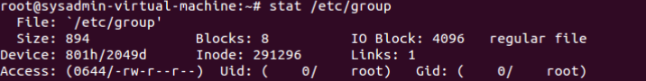

Part B:
Capture a screenshot of the results of each major command. Log on to Netlab2 (NISGTC Linux+ Series 2, Lab 01). Configure the below settings on the Fedora Workstation
Fedora 17 (17 is to old so I have do adapt Fedora 19 Controls)
3.5.3 Firewall Configuration (Configure iptables)

3.5.3.1.1 Ensure iptables is installed (Scored)
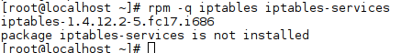
Iptables is installed but iptables-services is not installed
3.5.2.1 Ensure default deny firewall policy (Scored)
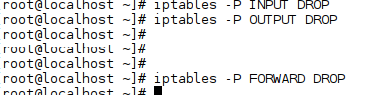
3.5.3.2.2 Ensure loopback traffic is configured (Scored)
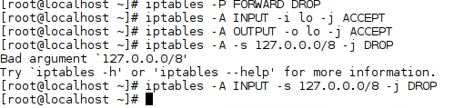
3.5.3.2.3 Ensure outbound and established connections are configured (Not Scored)
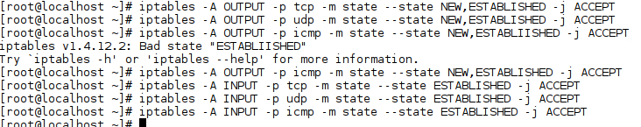
3.5.3.2.4 Ensure firewall rules exist for all open ports (Scored)
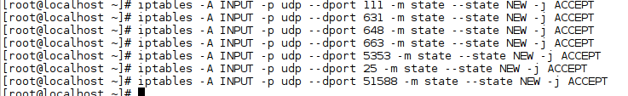

5.4.1 Set Shadow Password Suite Parameters

5.4.1.1 Ensure password expiration is 365 days or less
5.4.1.2 Ensure minimum days between password changes is 7 or more
5.4.1.3 Ensure password expiration warning days is 7 or more
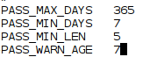
5.4.1.4 Ensure inactive password lock is 30 days or less
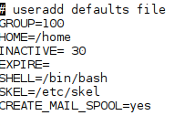

4.1.2 Configure Data Retention

4.1.2.1 Ensure audit log storage size is configured (Not Scored)
4.1.2.3 Ensure system is disabled when audit logs are full (Scored)
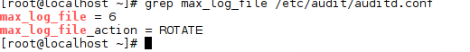
4.1.2.2 Ensure audit logs are not automatically deleted (Scored)
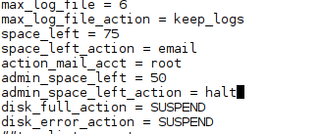
4.1.7 Ensure login and logout events are collected (Scored)
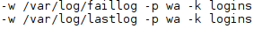
4.1.8 Ensure session initiation information is collected (Scored)
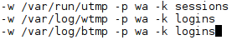
4.1.15 Ensure system administrator actions (sudolog) are collected (Scored)
4.1.17 Ensure the audit configuration is immutable (Scored)

6.1 System File Permissions

    - Audit system file permissions (Not Scored)
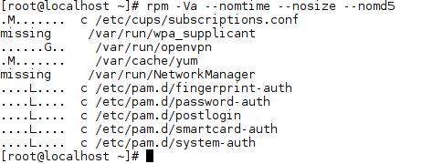
Issues cant be fixed as there is no internet connection
    - Ensure permissions on /etc/passwd are configured (Scored)
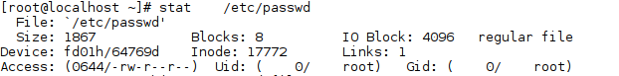
    - Ensure permissions on /etc/shadow are configured (Scored)
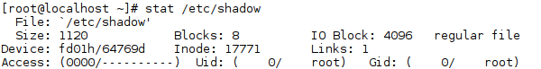
    - Ensure permissions on /etc/group are configured (Scored)
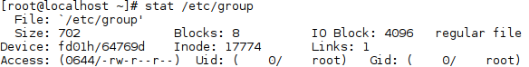

Part C:
Capture a screenshot of the results of each major command. Log on to Netlab2 (NISGTC Linux+ Series 2, Lab 01). Configure the below settings on the CentOS Server
Centos 6.3
3.6.1 Firewall Configuration

3.6.1.1 Ensure iptables is installed (Scored)
3.6.2.1 Ensure default deny firewall policy (Scored)
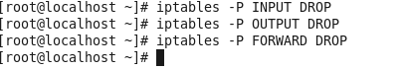
3.6.2.2 Ensure loopback traffic is configured (Scored)
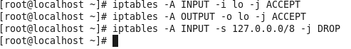
3.6.2.3 Ensure outbound and established connections are configured (Not Scored)
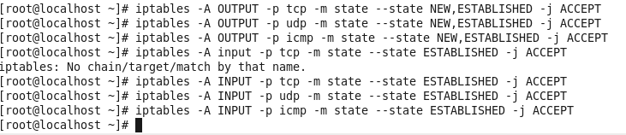
3.6.2.4 Ensure firewall rules exist for all open ports (Scored)
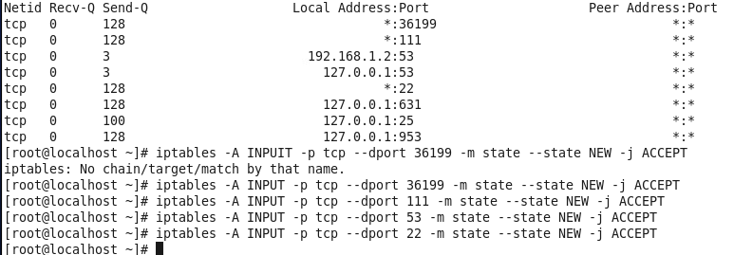

5.5.1 Set Shadow Password Suite Parameters

5.5.1.1 Ensure password expiration is 365 days or less
5.5.1.2 Ensure minimum days between password changes is 7 or more
5.5.1.3 Ensure password expiration warning days is 7 or more
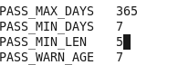
5.5.1.4 Ensure inactive password lock is 30 days or less
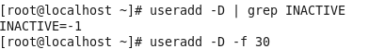

4.1.2 Configure Data Retention

4.1.2.1 Ensure audit log storage size is configured (Not Scored)
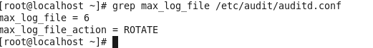
4.1.2.2 Ensure system is disabled when audit logs are full (Scored)
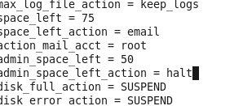
4.1.2.3 Ensure audit logs are not automatically deleted (Scored)
4.1.7 Ensure login and logout events are collected (Scored)
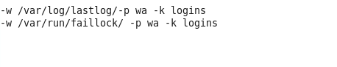
4.1.8 Ensure session initiation information is collected (Scored)
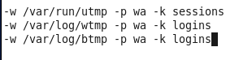
4.1.15 Ensure system administrator actions (sudolog) are collected (Scored)
4.1.17 Ensure the audit configuration is immutable (Scored)

6.1 System File Permissions

    - Audit system file permissions (Not Scored)
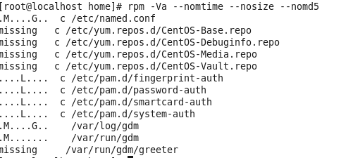
Cant make fixes and there is no intenet connection
    - Ensure permissions on /etc/passwd are configured (Scored)
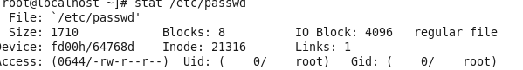
    - Ensure permissions on /etc/shadow are configured (Scored)
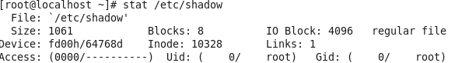
6.1.4 Ensure permissions on /etc/group are configured (Scored)
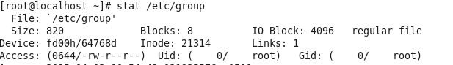

Configuration Settings:
3.6 Firewall Configuration

6.1 Ensure iptables is installed (Scored)
6.2 Ensure default deny firewall policy (Scored)
6.3 Ensure loopback traffic is configured (Scored)
6.4 Ensure outbound and established connections are configured (Not Scored)
6.5 Ensure firewall rules exist for all open ports (Scored)

5.4.1 Set Shadow Password Suite Parameters

4.1.1 Ensure password expiration is 365 days or less
4.1.2 Ensure minimum days between password changes is 7 or more
4.1.3 Ensure password expiration warning days is 7 or more
4.1.4 Ensure inactive password lock is 30 days or less

4.1.1 Configure Data Retention

1.1.1 Ensure audit log storage size is configured (Not Scored)
1.1.2 Ensure system is disabled when audit logs are full (Scored)
1.1.3 Ensure audit logs are not automatically deleted (Scored)
1.8 Ensure login and logout events are collected (Scored)
1.9 Ensure session initiation information is collected (Scored)
1.16 Ensure system administrator actions (sudolog) are collected (Scored)
1.18 Ensure the audit configuration is immutable (Scored)

6.1 System File Permissions

1.1 Audit system file permissions (Not Scored)
1.2 Ensure permissions on /etc/passwd are configured (Scored)
1.3 Ensure permissions on /etc/shadow are configured (Scored)
1.4 Ensure permissions on /etc/group are configured (Scored)

